Project Design Phase-II
Data Flow Diagram & User Stories

Date | 6 March 2025
Team ID | SWTID-2026-3503
Project Name | Libspace
Maximum Marks | 4 Marks

Data Flow Diagrams
A Data Flow Diagram (DFD) represents how information moves through a system. It illustrates the flow of data between users, processes, and storage components. DFDs help in understanding how the system processes input data, transforms it through different operations, and stores or outputs the resulting information. A clear DFD improves system design by visually explaining system requirements and interactions between different modules.

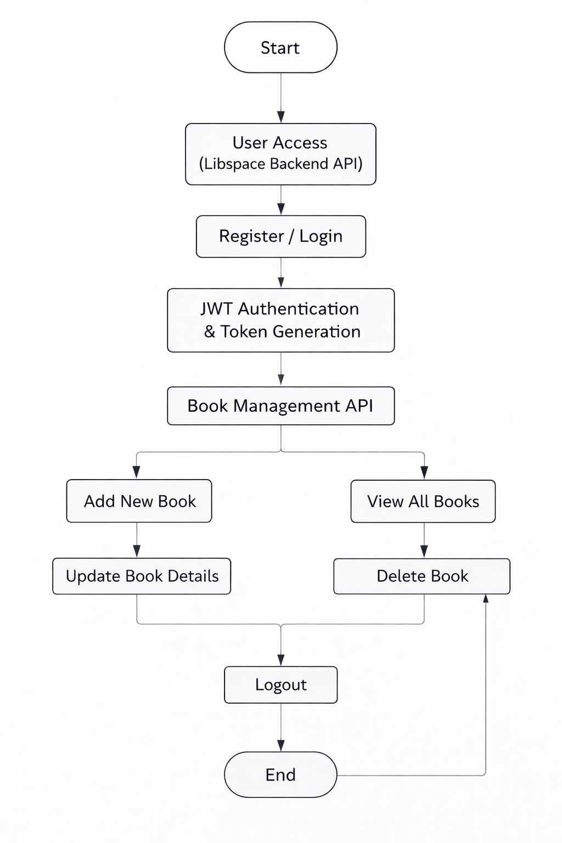
User Stories :
Use the below template to list all the user stories for the product.
User Type | User Story Number | User Story / Task | Acceptance criteria | Priority | Release
Customer  (Web user) | USN-1 | As a user, I can create an account using my email and password. | User details are stored securely in database and password is encrypted using bcrypt. | High | Sprint-1
Customer  (Web user) | USN-2 | As a user, I can login using my registered credentials. | JWT token is generated on successful login and user can access protected routes. | High | Sprint-1
Customer  (Web user) | USN-3 | As a user, I can add a new book to my account. | Book details are saved in database and linked to the logged-in user. | Low | Sprint-2

